**Do Better Schools Matter in Utah?**

**Estimating the Causal Effect of Better Elementary Schools on Housing Prices**

By Robert Prior

In a landmark paper, Charles Tiebout developed the theory now known as The Tiebout Model. This model helped establish economic theory on how people’s responses to public goods affect prices in the private market. This question of how people respond to the quality level of public goods is of great interest to politicians, parents, and homeowners. Specifically, we are reviewing the relationship between the quality of public elementary schools and the housing prices in those schools. If the theory is correct, housing prices would be greater in higher quality school and lower in worse quality schools. This natural sorting of where homeowners buy homes shows the revealed preferences of homeowners and how much they value quality elementary schools. Many assumptions must hold for the Tiebout Model to work effectively, some assumptions given by Lovenheim and Turner (2018) are adequate information on the quality of the school, the ability to move houses to and from different school boundaries, and multiple schools to choose from.

This paper will act as a replication study for Sandra E. Black’s paper, *Do Better Schools Matter? Parental Valuation of Elementary Education* (1999). The main difference between this paper and Sandra Black’s paper is a different geographic location which can speak to the robustness of Black’s findings regarding homogeneity in preferences across the geographic locations. The main similarities will be that we use a similar identification strategy and data modeling. The data that we use is MLS data for Utah County with the exception of Provo City, census block information, elementary school boundaries, and English, Math and Science test scores. The identification strategy we used was a geographic regression discontinuity comparing housing prices on either side of the elementary school boundary, controlling for various characteristics of the house and many fixed effects. The results of the study are mixed, but replicate Sandra Black’s findings. This means evidence that is mostly positive and statistically significant coefficients in favor of self-sorting according to preferences driving a significant effect on housing prices due to changes in test scores. This indicates a validation of the Tiebout Model.

The rest of the paper will continue as follows. Section I will look at some of the previous literature written about the subject. Section II will describe the data. Section III will outline our identification strategy and assumptions. Section IV will explain our results. Section V will conclude.

**Section I: Literature Review**

This paper attempts to replicate a study done by Sandra Black, whose paper *Do Better Schools Matter?* was published in the Quarterly Journal of Economics in 1999. In this paper, Black uses elementary school tests scores as a proxy for school quality and estimates the effect of elementary school test scores on housing prices. The question of interest is the size of the premium one will pay to increase the expected quality of their dependent’s education. Other studies have answered this question in different ways and questioned the best way to proxy school quality. Downes and Zabel (2002) found that one effective way to proxy school quality is through the use of pass rates on standardized proficiency tests. Black’s 1999 study proxies school quality with average standardized test scores. In this paper, we instead use proficiency test pass rates as Downes and Zabel suggest. This is one way in which studies have been done in the past to test willingness to pay for one’s dependent’s quality of education.

Black’s paper uses housing data from 1993 to 1995 that includes three counties in the suburban Boston area. Using the same empirical approach replicated herein, Black’s paper found that an increase in elementary school test scores of 5 percent causes a marginal increase in the willingness to pay of about 2.1 percent. Her paper also shows the identified effect to be robust to a number of sensitivity checks. She extrapolates from this finding to claim that elementary school quality is an important consideration of homebuyers and that her finding roughly represents the willingness to pay for one’s dependent’s education.

Black saw that neighborhood quality and school quality are often correlated, and that it is consequently difficult to identify the effect that school quality has on housing prices. She avoids this problem by estimating the effect of elementary school quality on housing prices by restricting housing data to incrementally smaller distances from attendance school district boundaries. This relies on the assumption that neighborhoods do not see a discrete change at school attendance boundaries, but school quality does.

Later studies have offered critiques to Black’s empirical approach. Chiodo et al (2010) offered three reasons why Black’s model could be improved by allowing for nonlinear effects. First, the authors argue that, as a consequence of buyer concentration in high-quality school attendance zones, the housing market in these areas may tighten, and consequently cause housing prices to rise since housing stock is generally fixed in the short run. Second, families can choose to live in a low-cost neighborhood and to have their children educated in a high-quality private school. This is not accounted for in Black’s study which, like our replication, looks only at public elementary schools. A third explanation for the possible generation of nonlinearities in the model would be the viewing of a high-quality education as a luxury good, which would cause those in more affluent neighborhoods to be willing to pay more for an equal marginal increase in value. However, Chiodo et al did not find results dissimilar in direction or magnitude to Black’s study as a consequence of allowing for nonlinearity. We estimate the effect of school quality on housing prices following an empirical approach closely comparable to Black’s.

**Section II: Data**

Test Score Data

This paper intends to estimate the effect that elementary school quality has on housing prices. Our proxy for elementary school quality is a school’s student proficiency rate in the Criterion Referenced Test (or CRT exam). This is used because it is comparable across all public elementary schools within the state. Additionally, Oppenheim (1989) showed evidence that suggests parents do consider test scores as a metric of elementary school quality. If this is not the case, however, test scores are expected to be correlated with other signifiers of school quality that parents do care about. Test scores, or more accurately proficiency rates on the CRT, are a proxy for school quality. The Utah State Board of Education gathers and publishes data on standardized testing including the CRT. There are three school districts represented within our area of interest, which is Utah County. Within Utah County, our housing data is split between 78 attendance school districts. The CRT includes three sections, which are math, reading, and science. We proxy school quality by using an average proficiency rate between the three categories. Refer to Table I for summary statistics of the test score data we used.

**Table I**

**Summary Statistics**

| Distance from boundary: | Full Sample | |  | 0.35 mile | |  | 0.20 mile | |  | 0.15 mile | |
| --- | --- | --- | --- | --- | --- | --- | --- | --- | --- | --- | --- |
|  | mean | S.D |  | mean | S.D |  | mean | S.D |  | mean | S.D |
|  |  |  |  |  |  |  |  |  |  |  |  |
| Ln(house price) | 12.39 | 0.40 |  | 12.41 | 0.40 |  | 12.41 | 0.42 |  | 12.41 | 0.42 |
| House Price | 267,702 | 382,906 |  | 274,412 | 468,839 |  | 277,976 | 570,671 |  | 284,067 | 649,549 |
|  |  |  |  |  |  |  |  |  |  |  |  |
| Avg. School Test Scorea | 78.28 | 8.20 |  | 78.67 | 7.69 |  | 78.83 | 7.55 |  | 79.02 | 7.60 |
| English Score | 81.65 | 7.05 |  | 81.68 | 6.62 |  | 81.78 | 6.50 |  | 81.87 | 6.58 |
| Math Score | 78.15 | 9.21 |  | 78.83 | 8.71 |  | 79.08 | 8.65 |  | 79.31 | 8.70 |
| Science Score | 75.04 | 9.94 |  | 75.50 | 9.31 |  | 75.62 | 9.14 |  | 75.88 | 9.16 |
|  |  |  |  |  |  |  |  |  |  |  |  |
| Bedrooms | 4.07 | 1.20 |  | 4.11 | 1.20 |  | 4.11 | 1.20 |  | 4.12 | 1.22 |
| Baths | 2.84 | 0.99 |  | 2.85 | 0.98 |  | 2.83 | 0.98 |  | 2.83 | 0.99 |
| Baths2 | 9.05 | 6.78 |  | 9.09 | 6.38 |  | 8.95 | 6.24 |  | 8.97 | 6.30 |
| Internal ft2 | 2,987 | 1,430 |  | 2,986 | 1,396 |  | 2,974 | 1,389 |  | 3,000 | 1,404 |
| Lot Size | 0.27 | 0.40 |  | 0.26 | 0.27 |  | 0.26 | 0.28 |  | 0.26 | 0.27 |
| Age of Building | 25.43 | 22.06 |  | 26.32 | 21.79 |  | 27.80 | 22.71 |  | 27.92 | 22.78 |
| Age2 | 1,134 | 2,265 |  | 1,167 | 2,242 |  | 1,288 | 2,378 |  | 1,298 | 2,385 |
|  |  |  |  |  |  |  |  |  |  |  |  |
| N | 6,018 | |  | 3,802 | |  | 2502 | |  | 1908 | |

a. Test scores are measured at the elementary school level and represent the average of the reading and math proficiency rates from the CRT exam. Source: Utah Board of Education.

MLS Housing Data

We used the MLS (Multiple Listing Service) for all cities in Utah County except for Provo City. This data contains information about the sale price and current characteristics of the houses. The data ranges from Jan 2008 - Jan 2010. We don’t use the data for Provo City because of lacking school boundaries data. It is important to know that the price used is not the listed price but the price actually paid by the buyer. This is important because we need to capture actual buying preferences. It is also important to note that the control characteristics that we used like the number of bedrooms and baths, Internal ft2 , etc. are not significantly changing the closer we get to the elementary school boundary. This would suggest that if changes occur to housing prices it is not due to changes in housing characteristics. Figure I shows the location of each sold house between Jan 2008 and Jan 2010.

**Figure 1**

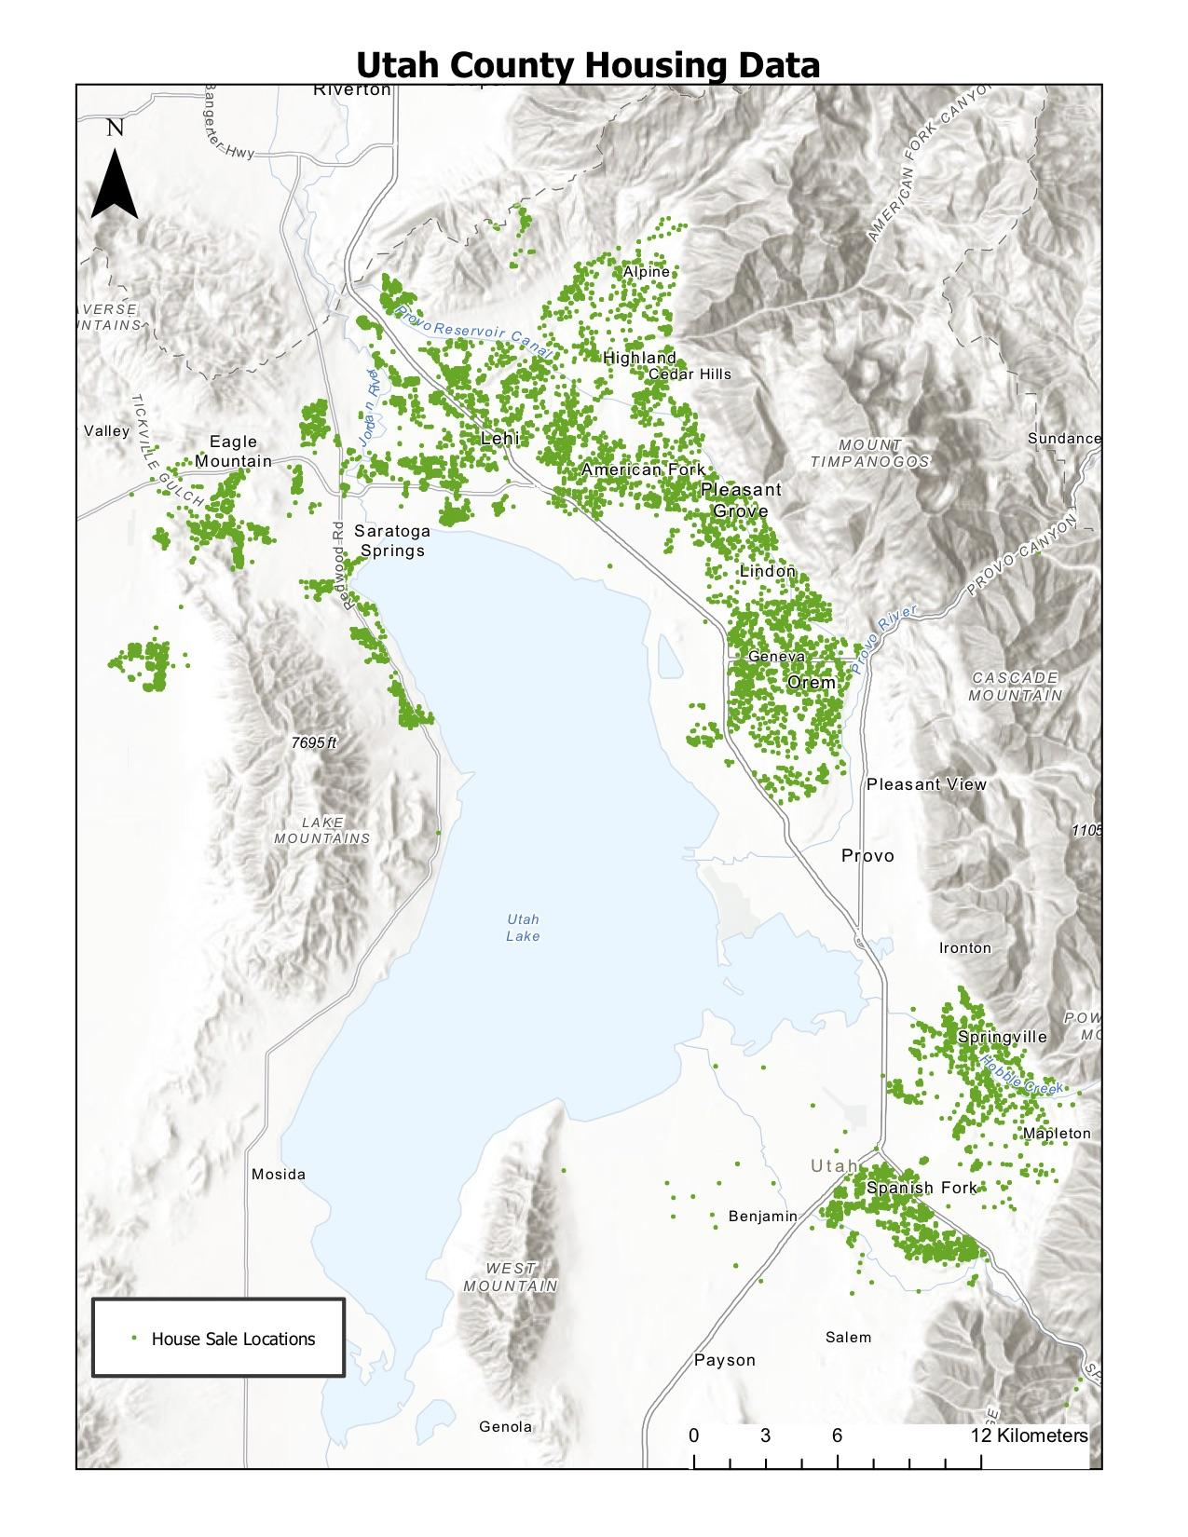

Attendance Boundaries Data

In our paper, we match housing data up with elementary school attendance boundaries. There are 84 elementary schools that make up our sample. These elementary schools are each grouped under one of the 3 school districts in our sample. These attendance boundaries for Utah County were obtained from the National Center for Education Statistics’ (NCES) School Attendance Boundary Survey data collection of attendance areas for 2009-2010. Due to the lack of data on attendance boundaries for areas of Provo, housing data for the corresponding areas were omitted from the study. Attendance boundaries next to geographical features such as Utah lake or a mountain range were removed from the sample. Students who live within the boundaries of a certain school but wish to attend a school for which they are out of the geographical boundary can file a request with the school board. This request goes through an appeal process where the request is reviewed conditional upon no disruption to the school’s allocation of funds and space permitting. The parents are also responsible to demonstrate an ability to appropriately provide daily transportation to and from school for the student, which is another barrier to transfer. With these constraints in mind, the ability to transfer is fairly restricted. There is the possibility of some attenuation bias due to this fact however.

Census Block Groups Data

We use census block groups as a fixed effect in our model to account for neighborhood characteristics within the sample. Census Block Groups are the smallest geographical units used by the United States Census Bureau, each having a population of between 600-3000 people. Each Block Group covers a contiguous area such as to avoid potential geographical features that would create distinct populations within the Block Groups. There are 295 Census Block Groups within our sample. Sandra Black matches up census block characteristics to each census block to account for neighborhood characteristics. Some of these census block variables she uses entail detailing age groups, race demographics, median household income, and education levels within each block group. When restricting the sample to certain distances from a shared boundary line, these variables are dropped from the regression. Due to time constraints leading us to focus on the spatially constrained regression model, we used census block fixed effects for the non-distance constrained model. These census block groups were obtained from Census Reporter used in the 2010 census.

**Figure 2**

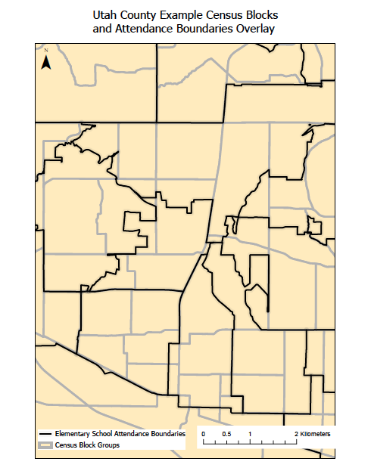

**Section III: Identification Strategy and Assumptions**

The identification assumption for this analysis is that the unobservables between houses right next to different elementary school attendance boundary areas are comparable after accounting for observable measures. This allows for the assumption that the only difference between houses in various attendance boundaries is the differing school quality of their geographically assigned elementary school. By proxying school quality with test scores, we are able to estimate this relationship between school quality and housing sale prices. A common approach taken by past studies looking to measure a similar relationship between house prices and elementary school quality has been to use the Hedonic pricing method. They use a similar equation as follows:

(1) ln (priceiaj) = α0 + α1Xiaj + α2Zj + α3testaj + εiaj

In this equation, priceiaj is the individual price of house “i” in attendance district “a” in school district “j”. The vector of Xiaj contains characteristics of house “i” and vector Zj contains neighborhood and school district characteristics. The main regressor in the model is testaj, which is the average test score of the elementary school that house “i” and other houses in attendance district “a” would attend.

An issue with this model is that it fails to account for potential bias from certain unobserved neighborhood characteristics. This failure to account for certain neighborhood effects potentially affecting school quality and house prices leads to omitted variable bias in particular. “There are two distinct types of omitted variable problems with this estimation. First, there are omitted variables that vary at the school district level, in particular, property tax rates and public goods provision. Second, there are omitted variables that can change over space, both within and across school districts, such as neighborhood characteristics” (Black, 1999). Property tax rates can be controlled for in this model but a quantifiable measure for public goods provision is challenging to find or create. The issue with omitted variables that change over space both within and across school districts is finding a way to group houses based on a grouping that is unknown. Sandra Black found a way to account for these issues in her paper. For both of the omitted variable problems, they can be reasonably accounted for by using an identification strategy that uses a regression discontinuity across boundary lines. In comparing houses on either side of a boundary, they are likely to be within the same city and subject to the same tax laws. By also restricting the sample of houses used to be within a certain distance on either side of a shared boundary line and controlling for observed characteristics, one can assume that houses are relatively homogenous in terms of their unobserved characteristics except through the quality of their assigned school. These observable characteristics include features of the individual houses and various geographical and time fixed effects. This is modeled as follows:

(2) ln (priceiab) = β0 + β1Xiab + β2Kb + β3testab + εiab

This is similar to the first equation except through the introduction of Kb, which is a vector of boundary dummies. This matches up houses within a given distance of a shared attendance boundary to create a spatial regression discontinuity of house prices across the shared boundary. This allows us to measure how the discrete jump in test scores at the boundary line affects housing prices while neighborhood characteristics remain fairly similar, allowing us to isolate the relationship between test scores and house price (Black, 1999).

This regression discontinuity approach allows us to match up houses within a specified constraining distance on the same side of a boundary line, and compare them to houses on the other side of a shared boundary line, accounting for these different potential sources of omitted variable bias. For the first type of omitted variable bias, this approach and city fixed effects help to account for any differences in school spending and property tax rates by comparing houses close together and thus in the same city, making this source of omitted variable bias no longer of concern. This makes test scores a better measure of school quality in that it only measures factors of the school such as quality of teachers and is no longer biased upwards through external financial factors such as funding. The second type of omitted variable bias, relating to neighborhood differences, is also assumed to be no longer of concern with this spatial regression discontinuity approach. By restricting the sample to houses relatively close to the attendance boundary, houses are more likely to share neighborhood characteristics. The ultimate goal of accounting for these additional factors is to obtain an unbiased estimate of the relationship between housing prices and school quality as proxied through test scores.

In order to assess the validity of our empirical approach to estimation, we looked for statistically significant correlation between characteristics of houses and school exam proficiency rates, which differ on either side of a school attendance boundary. We found there to be a positive, statistically significant correlation between the number of bedrooms and school exam proficiency rates. Other observable characteristics were not found to have a statistically significant correlation with test scores. In our case, this generally supports the assumption that our empirical approach to estimation gives a causal effect of elementary school proficiency exam scores on housing prices rather than housing prices being driven by the variation in another variable that is correlated to test scores.

**Section IV: Results**

Our results can be found on Table II and Table III with our magnitude of our results estimated on Table IV. The first regression in Table III is not restricting houses within a certain distance to the school boundary. This regression is what would happen without our identification strategy and reflects the outcomes without controlling for the endogeneity that can occur with better quality schools more likely to be found in better neighborhoods. This means there is omitted variable bias that still needs to be controlled. This regression has 6,018 observations and does not include the boundary fixed effects.

We included all the variables included in Table III. We deviated from Sandra Black’s paper by not including variables like percentages of Hispanics; non-Hispanic blacks; female-headed households with related children; people 25 or over with a bachelor's degree, a graduate degree, and who never finished high school; and the age distribution (divided into 0-9 years, 65 and older, and all others), per-pupil expenditures, the pupil/teacher ratio, and the existence of free or reduced-cost preschool programs [1999]. Though these control variables would be nice they are not crucial for our identifying assumption to remain effective.

Column (2) shows the regression when we restrict the data to houses that are within .35 miles from the nearest boundary line and include our boundary fixed effects. “As the sample is restricted to houses closer and closer to the boundary, it becomes less likely that there are differences other than the elementary school quality on opposite sides of the boundary” (Black 1999). Columns (3) and (4) represent estimations of equation (2) while restricting the sample to smaller and smaller distances from the attendance school boundary. We find a significant effect in the regressions outlined in columns (2), (3), and (4) of Table III.

Table II: Regression Results

Cluster Corrected Standard Errorsa

Dependent Variable = ln(House Sale Price)

| Basic Regressions | (1) | (2) |
| --- | --- | --- |
|  | Basics | Without Neighborhood Effects |
|  |  |  |
| Avg. School Test Scoreb | 0.0202*** | 0.00482*** |
|  | (0.00310) | (0.00176) |
| Bedrooms |  | 0.0134*** |
|  |  | (0.00364) |
| Baths |  | 0.106*** |
|  |  | (0.0262) |
| Baths2 |  | -0.0111*** |
|  |  | (0.00365) |
| Lot Size |  | 0.101*** |
|  |  | (0.0234) |
| Internal ft2 |  | 0.000184*** |
|  |  | (6.56e-06) |
| Age of Building |  | -0.00302*** |
|  |  | (0.00109) |
| Age Squared |  | 9.88e-06 |
|  |  | (7.70e-06) |
|  |  |  |
| Boundary Fixed Effects | NO | NO |
| Census Fixed Effects | NO | NO |
| Month Fixed Effects | NO | YES |
| Observations | 6,018 | 6,018 |
| Number of Boundaries | N/A | N/A |
| R-squared | 0.175 | 0.774 |
| *** p<0.01, ** p<0.05, * p<0.1  Adjusted Standard Errors in Parenthesis | | |

a. Standard errors are adjusted for clustering at the attendance school level. b. Test scores are measured at the elementary school level and represent the sum of the English, Reading, and Math proficiency rates from the CRT exam. Source: Utah Board of Education..

Table III: Regression Results

Cluster Corrected Standard Errorsa

Dependent Variable = ln(House Sale Price)

| Distance from Boundary: | (1) | (2) | (3) | (4) | (5) |
| --- | --- | --- | --- | --- | --- |
|  | All Housesb | 0.35 mile from boundary | 0.20 mile from boundary | 0.15 mile from boundary | 0.15 mile from boundary |
|  |  |  |  |  |  |
| Avg. School Test Scorec | 0.00182*** | 0.00150** | 0.00207** | 0.00238*** | 0.00175** |
|  | (0.000711) | (0.000655) | (0.000800) | (0.000792) | (0.000831) |
| Bedrooms | 0.0132*** | 0.0141*** | 0.0165*** | 0.0177*** | 0.0148*** |
|  | (0.00309) | (0.00394) | (0.00457) | (0.00547) | (0.00531) |
| Baths | 0.0642*** | 0.0471** | 0.0366** | 0.0385** | 0.0350* |
|  | (0.0184) | (0.0216) | (0.0162) | (0.0149) | (0.0185) |
| Baths2 | -0.00835*** | -0.00517 | -0.00393 | -0.00491* | -0.00464 |
|  | (0.00286) | (0.00317) | (0.00285) | (0.00250) | (0.00301) |
| Lot Size | 0.116*** | 0.186*** | 0.175*** | 0.196*** | 0.196*** |
|  | (0.0213) | (0.0325) | (0.0377) | (0.0434) | (0.0555) |
| Internal ft2 | 0.000167*** | 0.000172*** | 0.000173*** | 0.000176*** | 0.000171*** |
|  | (6.83e-06) | (7.28e-06) | (9.96e-06) | (1.06e-05) | (9.43e-06) |
| Age of Building | -0.00796*** | -0.00802*** | -0.00813*** | -0.00805*** | -0.00764*** |
|  | (0.000832) | (0.000897) | (0.00104) | (0.00113) | (0.00126) |
| Age Squared | 3.95e-05*** | 4.16e-05*** | 4.02e-05*** | 3.93e-05*** | 3.46e-05*** |
|  | (6.89e-06) | (7.20e-06) | (7.69e-06) | (8.19e-06) | (9.22e-06) |
|  |  |  |  |  |  |
| Boundary Fixed Effects | NO | YES | YES | YES | NO |
| Census Fixed Effects | YES | NO | NO | NO | YES |
| Month Fixed Effects | YES | YES | YES | YES | YES |
| Observations | 6,018 | 3,802 | 2,502 | 1,908 | 1,908 |
| Number of Boundaries | N/A | 150 | 144 | 139 | 139 |
| R-squared | 0.845 | 0.829 | 0.824 | 0.835 | 0.867 |
| *** p<0.01, ** p<0.05, * p<0.1  Adjusted Standard Errors in Parenthesis | | | | | |

a. Standard errors are adjusted for clustering at the attendance school level. b. This regression also includes school district fixed effects in addition to using the census block groups from the 2010 Census as neighborhood fixed effects. c. Test scores are measured at the elementary school level and represent the sum of the English, Reading, and Math proficiency rates from the CRT exam. Source: Utah Board of Education..

Evidenced from comparing the estimate on test scores from Table II column (2) to Table III, the estimate on test scores grows smaller and more significant with the inclusion of census group and district fixed effects in Table III column (1) or controlling for neighborhood effects by restricting the distance from a shared boundary to be smaller and smaller in columns (2) - (4) of Table III in our regression discontinuity model. This lends to the conclusion that the regression discontinuity is in fact accounting for neighborhood characteristics to reduce omitted variable bias in the models. In comparing columns (5) and (1) from Table III to each other, we can see that there is no statistical difference between the two estimates. This leads to the conclusion that the different coefficients on average school test scores from columns (2) - (4) in comparison to column (1) from Table III is not from a reduction in the sample size but is rather due to the underlying model differences used in the estimation of the effect of average school test scores on housing prices.

Table IV

Magnitude of Resultsa

|  | (1) | (2) | (3) | (4) |
| --- | --- | --- | --- | --- |
|  | Basic Hedonic Regressionc | 0.35 sample boundary fixed effects | 0.20 sample boundary fixed effects | 0.15 sample boundary fixed effects |
|  |  |  |  |  |
| Coefficient on elementary school test score | 0.00182 (0.000711) | 0.00150 (0.000655) | 0.00207 (0.000800) | 0.00238 (0.000792) |
|  |  |  |  |  |
| Magnitude of effect (percent change in house price as a result of a 5% change in average test scores)b | 0.91% | 0.75% | 1.035% | 1.19% |
|  |  |  |  |  |
| $ Value (at mean tax-adjusted house price of $267,000) | $2,430 | $2,003 | $2763 | $3,177 |
|  |  |  |  |  |

a. The results presented here are based on estimates from Table III, columns (1)-(4)

b. Roughly 0.625 of a one-standard-deviation change in the average test scores at the mean.

c. Regression includes house characteristics, school characteristics measured at the school district level, and neighborhood characteristics measured at the census block group level. See Table III, column (1), for more complete results.

In comparing our results to those dollar value estimates found in Sandra Black’s paper at the mean house prices, she found values, when adjusted for inflation to 2008 price levels, matched up to columns (1)-(4), to be $13560, $6365, $4981, and $5812 respectively. She found an interesting pattern in her results with her Hedonic model, equivalent to column (1) in Table IV, having the highest estimate of the results from Table IV, the opposite of the pattern found in our models’ results. This is potentially due to her Census Group and School District values accounting for neighborhood effects being distinctly different by using specific demographic characteristics to control for neighborhood effects in Census Block Groups and teacher per pupil ratio to control for district level effects. This could have lead to her controls accounting for less variation than the Census Group and School District fixed effects used in our model. In continuing that path of thinking, potentially our use of fixed effects accounts for a greater amount of any potential omitted variable bias, leading to the coefficient on test scores being smaller that Sandra Black’s estimate, specifically in relation to columns (2) - (4) from Table IV. This opens up a potential argument for the use of fixed effects to be a better tool in accounting for neighborhood characteristics or other characteristics through census groups or school districts than using a regression discontinuity design.

Our results are potentially also distinctly different from Sandra Black’s findings due to slightly different measures of test scores. Both her and our estimates are proficiency measures but she only uses the sum of Math and Reading scores in her estimates and are entered into the model as points out of 32. Our estimate uses Math, English, and Science scores and are entered into our data as as average percentages of the proficiency of all three scores. This leads to a slightly different interpretation of the results in our regression outputs but with the use of the Magnitude of Results tables, the estimation of the effects become more comparable. We also tested using just Math and English in computing the coefficient average tests scores to be more representative of Sandra Black’s use of Math and Reading scores. The difference in the use of the two different combinations of test scores was found to produce an insignificant difference on the coefficient for average school test scores with a z-score of 0.15. The difference in estimates of a 5% change in average test scores between our results in Table IV columns (2) - (4) and Sandra Black’s estimates of 2.3%, 1.8%, and 2.1% in respectively the same order as our results is also potentially reflective of underlying differences in preferences of the people in the respective geographical regions of Massachusetts and Utah.

Another reason that could make our results different than Sandra Black’s is the failure of assumptions of the Tiebout model, talked about in the introduction to this paper. For example, if school boundaries were not perfectly strict and would, on occasion, allow students to attend a school, in which they are not residing in that school boundary, the impact of test scores on housing prices would be attenuated. Another factor that could attenuate the results is if the adequate information assumption is violated. Although the testing data we obtained was publicly available, it was necessary to contact the Utah State Board of Education to find it. Information on the quality of schools can be hard to obtain for a lot of parents and if parents don’t become adequately informed about the differing quality of elementary schools then again our results trend towards zero.

**Section V: Conclusion**

Research on this topic seeks to determine the degree to which parents value elementary school quality. This paper was intended to test whether the findings published in Sandra Black’s 1999 paper *Do Better Schools Matter?* can be supported by a replication study using housing data and test scores from Utah County. We found evidence that a 5% increase in proficiency exam scores caused a 1.5-2.3% increase in housing prices within that attendance school boundary as per columns (2), (3), and (4) of Table IV. This is comparable to Sandra Black’s finding, which was that a 5% increase in test scores caused about a 2.1% increase in housing prices within the coordinating attendance school boundary. This paper serves as continued validation of the Tiebout Model, which asserts that higher tests scores should cause housing prices in an attendance school boundary to be higher.

**References**

Black, S. (1999). Do Better Schools Matter? Parental Valuation of Elementary Education. *The Quarterly Journal of Economics,114*(2), 577-599. Retrieved from <http://www.jstor.org/stable/2587017>

Chiodo et al. (2010). Nonlinear Effects of School Quality on House Prices. *Federal Reserve Bank of St. Louis Review*, May/June 2010, 92(3), 185-204. Retrieved from <https://files.stlouisfed.org/files/htdocs/publications/review/10/05/Chiodo.pdf>.

“Data and Statistics.” *Utah State Board of Education*, www.schools.utah.gov/data/reports.

Downes, TA, & Zabel, JE. (2002). The Impact of School Characteristics on House Prices. *Journal of Urban Economics*, 52(1), starting on page 1. Retrieved from<https://www.sciencedirect.com/science/article/pii/S0094119002000104>.

Lovenheim, M., & Turner, S. E. (2018). *Economics of education*. New York: Worth.

Tiebout, C. (1956). A Pure Theory of Local Expenditures. *Journal of Political Economy,* *64*(5), 416-424. Retrieved from http://www.jstor.org/stable/1826343